 | Project Design Phase-I
 | Solution Architecture
Date |  | 26 October 2022
Team ID |  | PNT2022TMID25349
Project Name |  | Personal Expense Tracker Application
Maximum Marks |  | 4 Marks

Solution Architecture:

Solution architecture is a complex process – with many sub-processes – that bridges the gap between business problems and technology solutions. Its goals are to:

- Find the best tech solution to solve existing business problems.

- Initialising the components in the correct sequence and connecting them up with each other when the app is launched.

- Shutting down the components and invoking clean-up methods where necessary when the app is shut down.

- Provide specifications according to which the solution is defined, managed, and delivered.

Example - Solution Architecture Diagram:
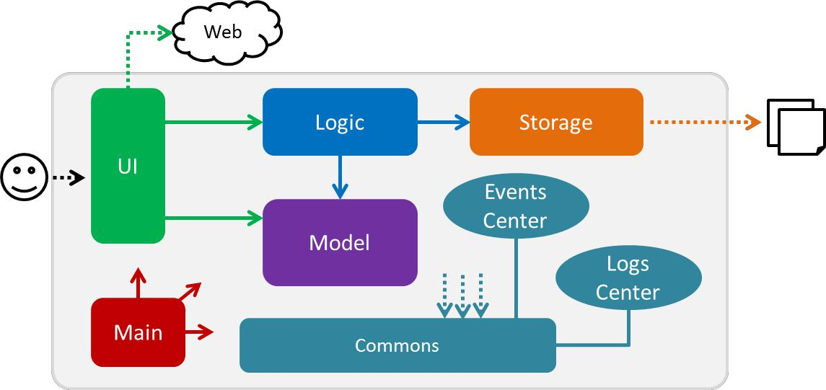

Figure 1: Architecture and data flow of the Personal Expense Tracker Application

